Azure

Azure Services

Compute
==> It is used to process data on the cloud by making use of powerful processors which serve multiple instances at a time.
Virtual Machines:
In Aws we have compute service like ec2 here we have in azure called as virtual machine.
==> To create a virtual Machine we need to select “virtual machine” column on left side-pane.
==> It will shows the no.of options for example to create a vm click on “create virtual machine”.

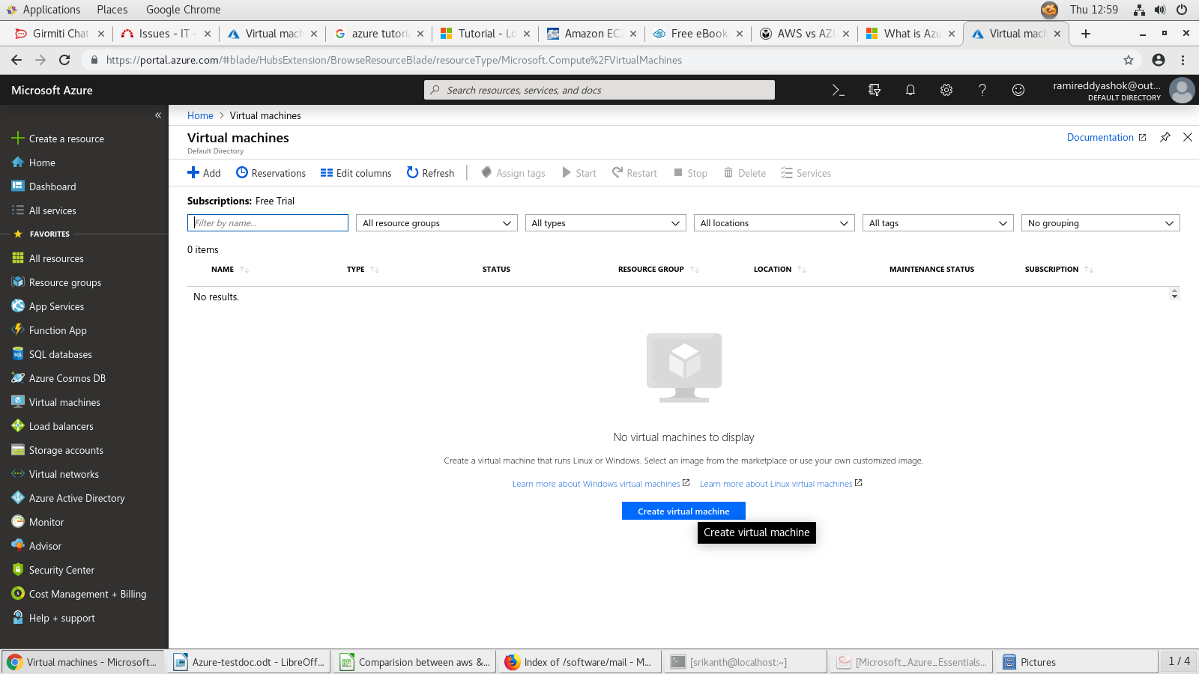

PROJECT DETAILS:
==> From The above snapshot we can see that just click on “create virtual machine”
==> Then it will asks us inputs like “resource groups”
==> These Resource Groups are nothing but folders to organize and manage all your resources.
==>we can create resource groups by clicking on “create new”
option by giving a name for your resources.
==>While Creating the resource group name please think about it should not contain any special characters like /,\,>,: ,|,@,#,&,^ etc.

INSTANCE DETAILS:
==>We have to provide instance details like “Virtual Machine Name , Region , Availability Options , Image , Size .
==> While Giving the name for a virtual machine there we have to follow that there should be unique name for the virtual machines in the current resource group && the name should be 64 chars long will be allowed.
==>After that we need to select Region for the vm that should be select from the these 27 regions available in azure.
==>Then We have to select the availability options that contains 3 sections we can select i)availability zone ii)availability set and the other one iii)No Infrastructure redundancy required.
==> Based On your requirement you can duplicate the resources by using above three options.
==> Choose the type of image that you want for the vm.
==>Here we have no.of images available for both
windows(2012 R2,2016,2019 Datacenters) & linux
servers(centos,SUSE,Debian,Ubuntu) and etc.
==> After that we need to select the vm size below are the types of sizes for the vms please have a look in the below screenshot.

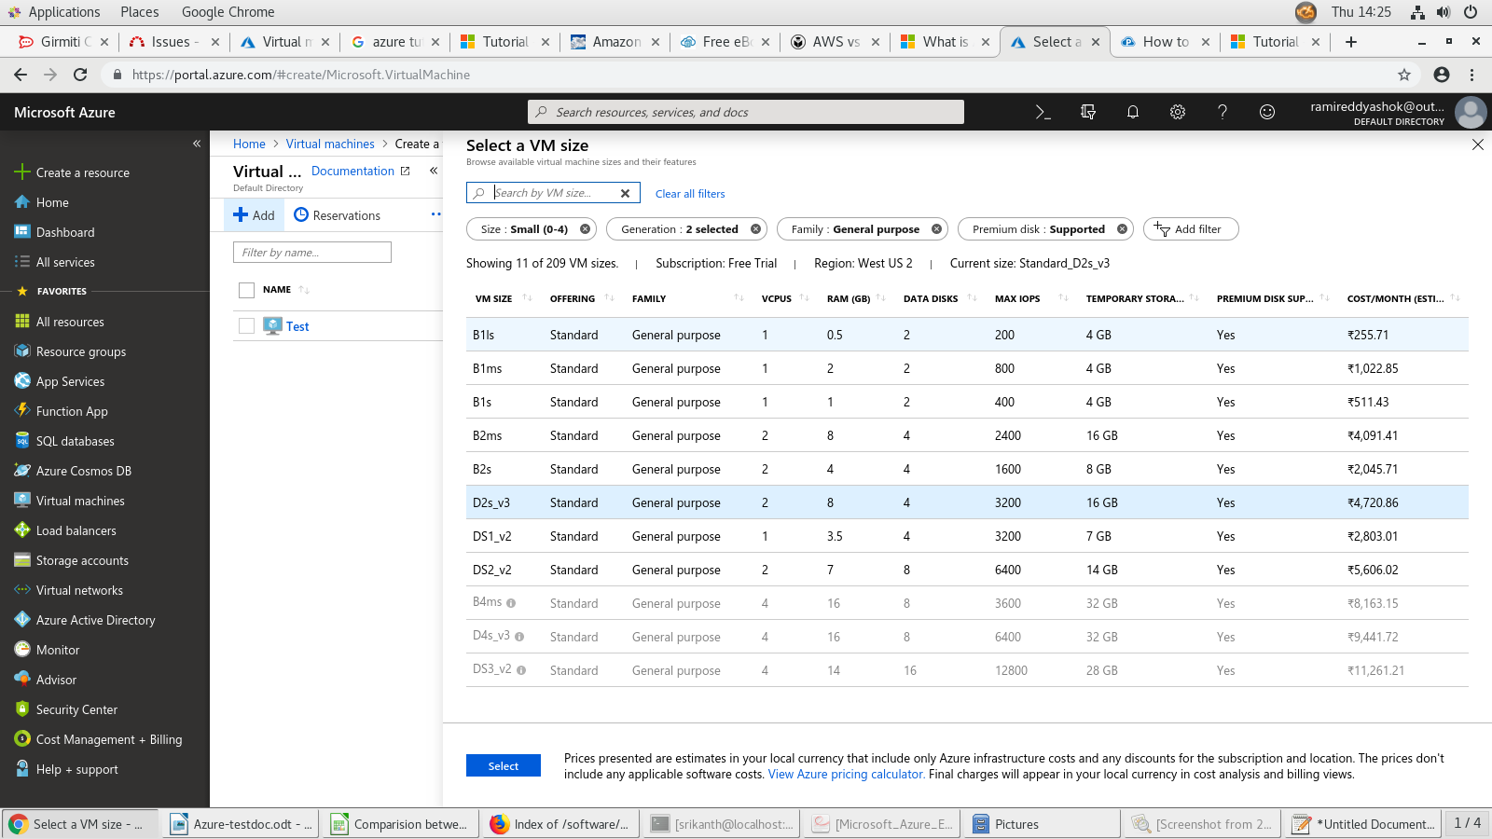

==> In azure for any size there will be a appropriate cost is issued as per your requirement you can choose the image size and click on select option.

ADMINISTRATOR ACCOUNT:
==> Then after we have other option which is Administrate Account for this authentication is required here we have two ways to authenticate this account i)By using User name & Password
and ii) By Using SSH public Key.
==> For the password there should be a strict length we have to provide atleast 13 to 27 chars and one letter should be In capital.

INBOUND PORT RULES:
==> Here in the azure we have a advantage which is we can allow the public traffic to a instance directly while creating the instance.
==> Here we can allow the the selected ports to a virtual machine or we have other way which is NETWORKING TAB(like security groups in aws).
==> Or we can select None Option which doesn’t allow the traffic to the vm.

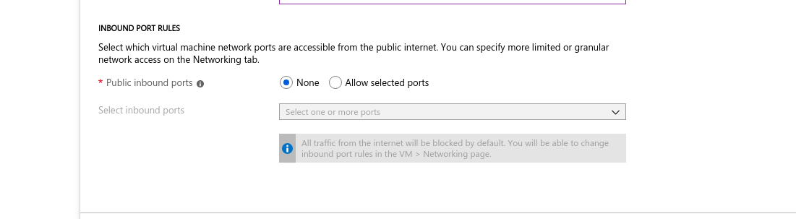
==> Next Click On Disks Option Here we have 3 Types of Disk which are 1) Premium SSD 2)Standard SSD 3)Standard HDD
==>Next Click on Networking Its like Security Groups in aws.
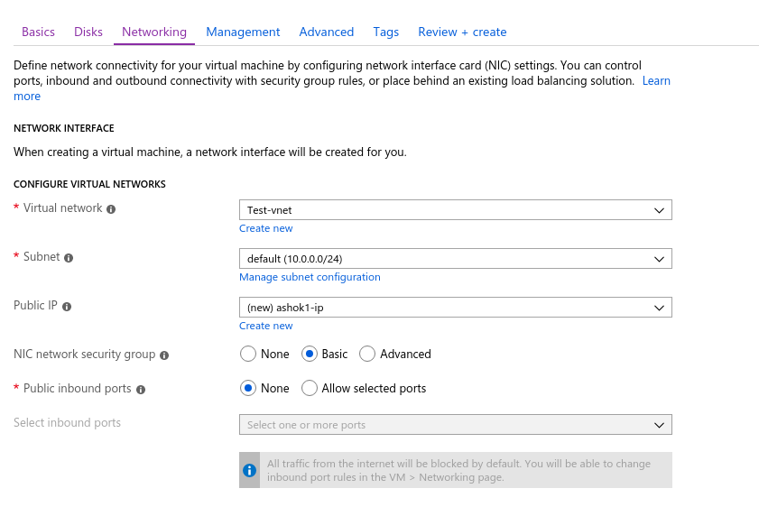

Configure Virtual Networks:
Configure Virtual Networks:
==>Create a Virtual Network by clicking on create new button.
==> Provide the Subnet Range.
==>create a public-ip address if you want to communicate with vm from outside virtual network.
NIC Security Group:
==>for this we have 3 options they are i)None ii)Basic iii)Advanced.
==>If You Select “None” Then All ports will be exposed to the public Network , This will be a security Risk.
==> If you Select “Basic” then by default all the traffic from internet will be blocked.
==> If click on “Basic” it will shows i)None And ii)Allow selected Ports.
==>if we selected Allow Selected Ports then we can allow some ports right from here They are i)Http-80 ii)Https-443 iii)SSH-22
iv)RDP-3389.
Accelerated networking:
==>It will Enables low latency and high throughput on the network interface.

Load Balancing:
==> If you want to put this vm in the load balancing pool you can check on the Yes(radio button). Then it will shows the existing load balancer Details.
==> Otherwise you can create other load balancer.

==> Click on Next:Management.

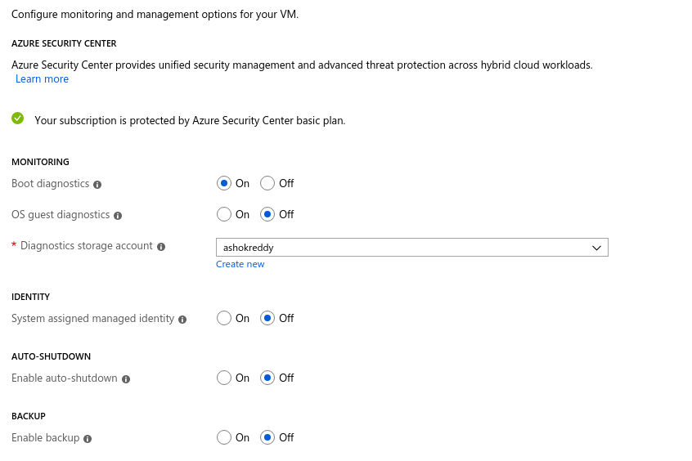
==>In this Management Section we have 4 Attributes which are Monitoring,Identity,Auto-Shutdown,Backup.
==>According our Priority we can enable or disable the above attributes.

==> Then Click On Next to Advanced.
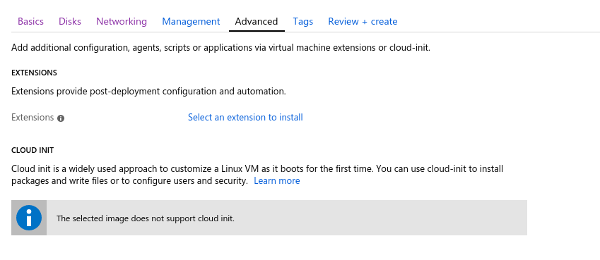
==> In this Advanced section we can add the extensions for adding the configuration management or Anti-virus Protection to the particular virtual machine.
==> Click On Next to Tags part.
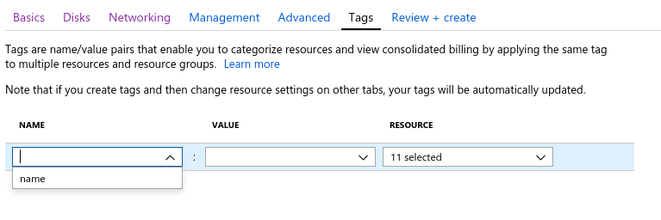

==> Here we can Provide the Name And Value for the Instance.
==> Then At last click on review and create to create the virtual machine.
==> We will Get the Info like below after click “create”.
